# Table Schema I created:

1. Branch ( BranchID [PK], BranchSuburb, BranchState )

2. Member ( MemberID [PK], MemberStatus, MemberName, MemberAddress,

MemberSuburb, MemberState, MemberExpDate, MemberPhone )

3. Publisher ( PublisherID [PK], PublisherName, PublisherAddress )

1. Book ( BookID [PK], BookTitle, PublisherID [FK], PublishedYear, Price )

5. Author ( AuthorID [PK], AuthorName, AuthorAddress )

6. Authoredby ( BookID [FK], AuthorID [FK] )

7. Holding ( BranchID [FK], BookID [FK], InStock, OnLoan )

8. Borrowedby ( BookIssueID [PK], BranchID [FK], BookID [FK], MemberID [FK], DateBorrowed, DateReturned, ReturnDueDate )

# Task1:

First we will check the member table:

Select * from member;

We have the data as following table:  
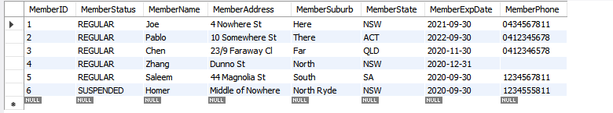  
  
Now we add Log Fee colume due to the task: **Update the Member table to allow logging fine fees for overdue.**

The SQL script for it:

ALTER TABLE Member ADD FineFees DECIMAL(10, 2) DEFAULT 0.00;

Then Select * from member; again you will see new column added  
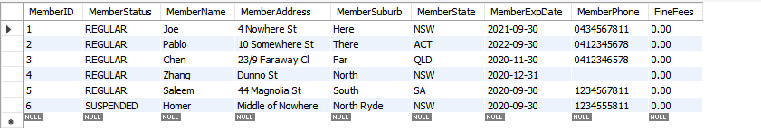

Or better way you can use DESC Member; to show the table structure:  
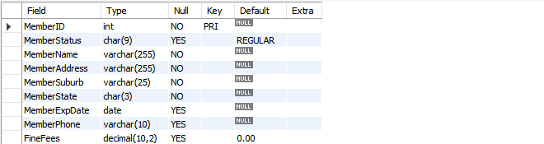  
  
As you can see the new field was added in the member table.

However, since it is default so every fee is 0.00.  
  
According to BR6 and BR7:

BR6. If a member has an outstanding fee* and it has reached $30, his/her membership will be suspended.

BR7. If a member has an overdue item, his/her fine fee will be increased $2/day passing the expiraUon date and the membership will be suspended.

So here is the additional script to update the fee so it match the rules:  
(in real life this should me run daily)  
  
UPDATE Member m

JOIN (

SELECT bb.MemberID,

COUNT(*) * 2 AS DailyFine -- $2 for each overdue book

FROM Borrowedby bb

WHERE bb.DateReturned IS NULL AND bb.ReturnDueDate < CURDATE()

GROUP BY bb.MemberID

) AS OverdueFees ON m.MemberID = OverdueFees.MemberID

SET m.FineFees = m.FineFees + OverdueFees.DailyFine;

The above script will update the fee. After run that script you can run Select * from member to check:

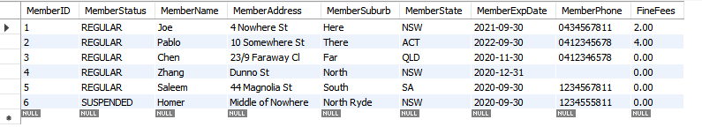

Then you need to suspend member with over $30:

UPDATE Member

SET MemberStatus = 'SUSPENDED'

WHERE FineFees >= 30 AND MemberStatus = 'REGULAR';  
  
since nobody has exceed it according the previous table so nothing change here. But in real life you might run it daily and it will update it.

# Task2:

We need a trigger for BR8.

**BR8 said**: When a suspended member clears their fine (i.e, paid all the outstanding fees) and has no or has

returned all overdue items, reset the member’s membership status to “REGULAR

To determine if a member has overdue items, we'd check the Borrowedby table's DateReturned and ReturnDueDate columns.

The conditions to check is:

- Check if the fine has been cleared (fee is 0.00).

- Check if the member has no overdue books.

- If both conditions are met, reset the member status to 'REGULAR'.

The script for it is:

DELIMITER //

CREATE TRIGGER BR8_Trigger

BEFORE UPDATE ON Member

FOR EACH ROW

BEGIN

DECLARE hasOverdue INT DEFAULT 0;

-- Error Handler

DECLARE CONTINUE HANDLER FOR SQLEXCEPTION

BEGIN

-- Return an error message

SIGNAL SQLSTATE '45000' SET MESSAGE_TEXT = 'An error occurred while updating the Member Status.';

END;

-- Check if there are overdue items for the member

SELECT COUNT(*)

INTO hasOverdue

FROM Borrowedby

WHERE MemberID = NEW.MemberID AND DateReturned IS NULL AND ReturnDueDate < CURDATE();

-- If the FineFees are 0.00 and there are no overdue items, set the MemberStatus to REGULAR

IF NEW.FineFees = 0.00 AND hasOverdue = 0 THEN

SET NEW.MemberStatus = 'REGULAR';

END IF;

END //

DELIMITER ;

The DELIMITER is for wrap the code because in side it also have the semi colon “;”.

Then you create Trigger and activate when there is an update for member table (each row)

There is also error handler for SQLEXCEPTION  
  
After all of that we start to check the overdue item with the script:

SELECT COUNT(*)

INTO hasOverdue

FROM Borrowedby

WHERE MemberID = NEW.MemberID AND DateReturned IS NULL AND ReturnDueDate < CURDATE();

This SQL query counts the number of overdue items for the updated member. It checks for borrowed items that haven't been returned (DateReturned IS NULL) and whose return due date has passed (ReturnDueDate < CURDATE()). The result is stored in the hasOverdue variable.

Now we update the member status:

IF NEW.FineFees = 0.00 AND hasOverdue = 0 THEN

SET NEW.MemberStatus = 'REGULAR';

END IF;

This block checks two conditions:

The fine fees for the updated member are 0 (NEW.FineFees = 0.00).

The member has no overdue items (hasOverdue = 0).

If both conditions are true, the member's status is updated to REGULAR.

# Task 3

we need: Write a stored procedure to list the members that currently have an overdue item and their (individual)

membership has been suspended twice in the past three years. End these members’ membership by sefng their

MemberStatus to “TERMINATED”. And also handle the exception

I notice there is no way to know who has been suspended twice in last three years so we need to create new table for it  
  
CREATE TABLE MemberHistory (

HistoryID INT NOT NULL AUTO_INCREMENT,

MemberID INT NOT NULL,

OldStatus VARCHAR(255) NOT NULL,

NewStatus VARCHAR(255) NOT NULL,

ChangeDate DATE NOT NULL,

PRIMARY KEY (HistoryID),

CONSTRAINT member_fk_3 FOREIGN KEY (MemberID) REFERENCES Member (MemberID) ON DELETE CASCADE

);

This to store data for user to know the status change they have.

Here is the script for the above task:

DELIMITER //

CREATE PROCEDURE TerminateOverdueMembers()

BEGIN

DECLARE currentDate DATE;

SET currentDate = CURDATE();

-- Drop temporary tables if they exist

DROP TEMPORARY TABLE IF EXISTS TempOverdueMembers;

DROP TEMPORARY TABLE IF EXISTS TempSuspendedMembers;

-- Find members who have overdue items

CREATE TEMPORARY TABLE TempOverdueMembers AS

SELECT DISTINCT MemberID

FROM Borrowedby

WHERE DateReturned IS NULL

AND currentDate > ReturnDueDate;

-- Find members who were suspended twice or more in the last three years using MemberHistory

CREATE TEMPORARY TABLE TempSuspendedMembers AS

SELECT MemberID

FROM MemberHistory

WHERE NewStatus = 'SUSPENDED'

AND ChangeDate BETWEEN DATE_SUB(currentDate, INTERVAL 3 YEAR) AND currentDate

GROUP BY MemberID

HAVING COUNT(MemberID) >= 2;

-- Update the status of the members who meet both criteria to 'TERMINATED'

UPDATE Member

SET MemberStatus = 'TERMINATED'

WHERE MemberID IN (

SELECT o.MemberID

FROM TempOverdueMembers o

JOIN TempSuspendedMembers s ON o.MemberID = s.MemberID

);

-- Drop temporary tables

DROP TEMPORARY TABLE IF EXISTS TempOverdueMembers;

DROP TEMPORARY TABLE IF EXISTS TempSuspendedMembers;

END //

DELIMITER ;

Again the DELIMITER is to wrap the code so it allow “;” in the code block inside.

First you create the procedure.

Then you handle the exception, If any SQL exception occurs while the procedure is running, the changes made inside this procedure will be reverted using the ROLLBACK command. This ensures that if part of the procedure fails, any changes made before that point aren't saved to the database.

Then you Start Transaction; To allow sequence of one or more SQL operations executed as a single logical unit of work. The benefit is that you can ensure that a series of operations are all successful before making permanent changes to the database. If any operation within the transaction fails, you can revert all the changes using the ROLLBACK command.

Now you Update Members Status:

UPDATE Member

SET MemberStatus = 'TERMINATED'

WHERE MemberID IN (

SELECT o.MemberID

FROM TempOverdueMembers o

JOIN TempSuspendedMembers s ON o.MemberID = s.MemberID

);

The above code updates the MemberStatus to 'TERMINATED' for members that meet specific criteria:

- Have overdue items.

- Have a 'SUSPENDED' status.

- Have been suspended twice or more in the past three years.

The logic for each of these criteria is nested within the WHERE clause.

Then commit to close transaction

Task4:

After creating the Trigger for task2 and Procedure for task 3. It’s time to test it:

Task2-Test (Testing the Trigger from Task 2):

Test Plan:

1. Scenario 1 (Overdue Item with Fine Reset):

* Description: A member who has an overdue book but has paid their fine fees.
* Expected Result: Their MemberStatus should not be set to 'REGULAR' after updating the fine fees to 0 because he have overdue book
* Test Data:

MemberID: 7

FineFees: 50

Overdue books: 1

Testing:

First insert that member and see the current data:

INSERT INTO Member (MemberID, MemberStatus, MemberName, MemberAddress, MemberSuburb, MemberState, MemberExpDate, MemberPhone, FineFees)

VALUES ('7', 'REGULAR', 'TestMember1', '123 Test St', 'TestTown', 'NSW', '2024-12-31', '1234567890', 50.00);

select * from member

We will have

  
  
Then we add borrow so this user have overdue item:

INSERT INTO Borrowedby (BranchID, BookID, MemberID, DateBorrowed, DateReturned, ReturnDueDate)

VALUES ('1', '1', '7', '2023-01-01', NULL, '2023-01-14');

Now update the fine fees to see if it getting back status to regular

UPDATE Member SET FineFees = 0 WHERE MemberID = 7;

We have



The Member Status unchange due to overdue book

1. Scenario 2 (No Overdue Item with Fine Reset):

* Description: A member who doesn't have any overdue books and has paid their fine fees.
* Expected Result: Their MemberStatus remains 'REGULAR' after updating the fine fees to 0.
* Test Data:

MemberID: 8

FineFees: 5

Overdue books: 0

Insert Data and check

INSERT INTO Member (MemberID, MemberStatus, MemberName, MemberAddress, MemberSuburb, MemberState, MemberExpDate, MemberPhone, FineFees)

VALUES ('8', Suspended, 'TestMember2', '456 Test Ave', 'TestCity', 'QLD', '2024-12-31', '0987654321', 5.00);  
  
Select * from member

Now we have:



Now update the fee. (no need added the overdue book)

Now it got back to regular: 

Task3-Test (Testing the Stored Procedure from Task 3):

Test Plan:

1. Scenario 1 (Member with Overdue Items, Suspended Twice in Last 3 Years):

* Description: A member who has overdue items and has been suspended twice in the last three years.
* Expected Result: Their MemberStatus should be set to 'TERMINATED'.
* Test Data:

MemberID: 10

MemberStatus: 'SUSPENDED'

Overdue books: 2

Suspensions in Last 3 Years: 2

First insert needed data:

Insert member data

INSERT INTO Member (MemberID, MemberStatus, MemberName, MemberAddress, MemberSuburb, MemberState, MemberExpDate, MemberPhone, FineFees)

VALUES (10, 'SUSPENDED', 'TestMember3', '789 Test Road', 'TestVille', 'VIC', '2024-12-31', '1122334455', 10.00);

.Insert data indicating this member has borrowed 2 books and both are overdue.

INSERT INTO Borrowedby (BranchID, BookID, MemberID, DateBorrowed, DateReturned, ReturnDueDate)

VALUES ('1', '2', '10', '2023-01-01', NULL, '2023-01-14');

INSERT INTO Borrowedby (BranchID, BookID, MemberID, DateBorrowed, DateReturned, ReturnDueDate)

VALUES ('1', '3', '10', '2023-01-02', NULL, '2023-01-15');

Insert history suspended:

INSERT INTO MemberHistory (MemberID, OldStatus, NewStatus, ChangeDate)

VALUES (10, 'REGULAR', 'SUSPENDED', '2021-02-01');

INSERT INTO MemberHistory (MemberID, OldStatus, NewStatus, ChangeDate)

VALUES (10, 'REGULAR', 'SUSPENDED', '2022-01-01');

The member should be: 

Call the procedure and her should be:



Remeber that you must  


Becasuse terminated has 10 character and default creation has 9 for member status:

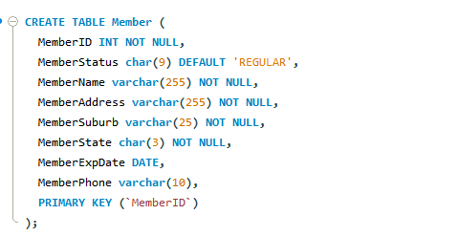

1. Scenario 2 (Member without Overdue Items, Suspended Twice in Last 3 Years):

* Description: A member who doesn't have overdue items but has been suspended twice in the last three years.
* Expected Result: Their MemberStatus should remain 'SUSPENDED' or any previous state.
* Test Data:

MemberID: 11

MemberStatus: 'SUSPENDED'

Overdue books: 0

Suspensions in Last 3 Years: 2

Insert the member data for testing

INSERT INTO Member (MemberID, MemberStatus, MemberName, MemberAddress, MemberSuburb, MemberState, MemberExpDate, MemberPhone, FineFees)

VALUES (11, 'SUSPENDED', 'TestMember4', '321 Test Blvd', 'TestBorough', 'SA', '2024-12-31', '6655443322', 0.00);

Insert data in MemberHistory to indicate the member was suspended twice in the last three years.

INSERT INTO MemberHistory (MemberID, OldStatus, NewStatus, ChangeDate)

VALUES (11, 'REGULAR', 'SUSPENDED', '2021-02-15');

INSERT INTO MemberHistory (MemberID, OldStatus, NewStatus, ChangeDate)

VALUES (11, 'REGULAR', 'SUSPENDED', '2022-02-15');

The data should be



And call the procedure it should remain



Because it has no overdue item

1. Scenario 3 (Member with Overdue Items, Suspended Only Once in Last 3 Years):

* Description: A member who has overdue items but has been suspended only once in the last three years.
* Expected Result: Their MemberStatus should remain 'SUSPENDED' or any previous state.
* Test Data:

MemberID: 12

MemberStatus: 'SUSPENDED'

Overdue books: 2

Suspensions in Last 3 Years: 1

Insert the member data for testing

INSERT INTO Member (MemberID, MemberStatus, MemberName, MemberAddress, MemberSuburb, MemberState, MemberExpDate, MemberPhone, FineFees)

VALUES (12, 'SUSPENDED', 'TestMember5', '654 Test Lane', 'TestDistrict', 'TAS', '2024-12-31', '7766554433', 10.00);

Insert data indicating this member has borrowed 2 books and both are overdue.

INSERT INTO Borrowedby (BranchID,BookID,MemberID,DateBorrowed,DateReturned,ReturnDueDate)

VALUES ('1', '1','12','2023-01-03',NULL,'2023-01-16');

INSERT INTO Borrowedby (BranchID,BookID,MemberID,DateBorrowed,DateReturned,ReturnDueDate)

VALUES ('1', '3','12','2023-01-05',NULL,'2023-01-18');

Insert data in MemberHistory to indicate the member was suspended once in the last three years.

INSERT INTO MemberHistory (MemberID, OldStatus, NewStatus, ChangeDate)

VALUES (12, 'REGULAR', 'SUSPENDED', '2022-03-01');

The data should be:



After call procedure it should be:



Because it only suspended once.